PROJECT REPORT

On

All in one booking site

Submitted in fulfillment of the requirement for the Course BEE (22CS026)

of

COMPUTER SCIENCE AND ENGINEERING

B.E. Batch-2022

in

Jan-2024



**Submitted By**

**Name:** Sunaina

**Roll. No:** 2210990875

**Under the Guidance of**

Ms. Shaffu

**DEPARTMENT OF COMPUTER SCIENCE AND ENGINEERING**

**CHITKARA UNIVERSITY**

**PUNJAB**

**CERTIFICATE**

This is to be certified that the project entitled *“All in one Booking”* has been submitted for the Bachelor Computer Science Engineering at Chitkara University, Punjab during the academic semester July 2024- December 2024 is a bonafide piece of project work carried out by *Sunaina(2210990875)* of the Group 13 towards the partial fulfillment for the award of the course Integrated Project (CS 203) under the guidance of "Ms. Shaffu" and supervision.

**Sign. of Project Guide:**Ms. Shaffu

Department Of Computer Science and Engineering

**CANDIDATE'S DECLARATION**

I SUNAINA (2210990875) Of Group 13, B.E.-2022 of the Chitkara University, Punjab hereby declare that the Integrated Project Report entitled "ALL IN ONE BOOKING SITE" is an original work and data provided in the study is authentic to the best of our knowledge. This report has not been submitted to any other Institute for the award of any other course.

**Sign. of Student**

**Name:** Sunaina

**Roll No:** 2210990875

**Place:** Patiala

**Date:**2/10/2024

**ACKNOWLEDGEMENT**

It is our pleasure to be indebted to various people, who directly or indirectly contributed in the development of this work and who influenced my thinking, behavior and acts during the course of study.

We express our sincere gratitude to all for providing me a part of the curriculum. opportunity to undergo Integrated Project as the part of curriculum.

We are thankful to "Ms Shaffu" for her support, cooperation, and motivation provided to us during the training for constant inspiration, presence and blessings.

We also extend our sincere appreciation to "Vimal Sir" who provided his valuable suggestions and precious time in accomplishing our integrated project report.

Lastly. We would like to thank the almighty and our parents for their moral support and friends with whom we shared our day-to day experience and received lots of suggestions that improve our quality of work.

**Name:** Sunaina

**Roll No:**2210990875

**Index**

|  |  |  |
| --- | --- | --- |
| **Sr. no** | **Topic** | **Page No** |
|  | Abstract/Keywords | 1 |
|  | Introduction to the Project | 2 |
|  | Software and Hardware Requirement Specification | 3 |
|  | Database Analyzing, Design, and Implementation | 4 |
|  | Program's Structure Analyzing and GUI Constructing | 11 |
|  | Code Implementation and Database Connections | 13 |
|  | System Testing | 17 |
|  | Limitations | 17 |
|  | Conclusion | 18 |
|  | Future Scope | 18 |
|  | Bibliography References | 19 |

1. **Abstract**
   1. **Abstract**

The **All-in-One Booking Site** is an innovative platform designed to provide users with a seamless and efficient booking experience for services across various categories. Developed using the MERN stack (MongoDB, Express.js, React.js, and Node.js), the platform combines robust backend infrastructure with an intuitive frontend interface to deliver a feature-rich application that caters to both individual users and service providers.

The primary goal of the platform is to simplify the process of managing bookings, offering users a centralized system where they can explore available services, make reservations, and provide feedback. Key functionalities include user registration, authentication, and profile management to ensure secure and personalized interactions. Service providers can register and list their offerings, allowing users to browse services across multiple categories. The platform's interface is designed for ease of use, ensuring that users can search, filter, and book services with minimal effort.

One of the core strengths of the All-in-One Booking Site is its integration of advanced features, such as location-based booking. Users can search for services near their desired location, enhancing the relevance and convenience of results. Additionally, the platform includes a review and rating system, promoting transparency and enabling users to make informed decisions based on other customers’ experiences.

The backend, powered by MongoDB and Express.js, ensures scalable and efficient data management while maintaining data security and integrity. The React.js-based frontend provides a responsive and user-friendly interface, while Node.js facilitates seamless server-side operations. The site supports CRUD (Create, Read, Update, Delete) functionalities for users, services, bookings, categories, and reviews, making it versatile and easy to manage for administrators and service providers.

Scalability and flexibility are key design considerations, ensuring that the platform can grow to accommodate increasing user demands and additional service categories. The system’s architecture emphasizes efficiency, enabling smooth operations even under high usage scenarios.

Overall, the All-in-One Booking Site is a reliable solution for bridging the gap between service providers and users. By integrating modern technologies and focusing on usability, the platform addresses real-world booking challenges, delivering a structured, interactive, and efficient system for managing diverse service needs. This project demonstrates a blend of technical innovation and practical utility, making it a valuable tool in the booking domain.

* 1. **Keywords**
* Online Booking System
* Fully Functional Platform
* Real-Time Updates
* MERN Stack
* Booking System
* Secure Authentication
* Scalable Infrastructure
* User Engagement

1. **Introduction**

The **All-in-One Booking Site** is a comprehensive platform developed to simplify and enhance the process of booking services across various categories. It caters to both individual users and service providers by offering a unified and intuitive interface for managing bookings. The platform addresses the challenges associated with decentralized booking systems, such as limited accessibility, lack of transparency, and inefficiency in managing user interactions. By integrating modern technologies, it ensures a seamless experience for all stakeholders, creating a structured and reliable solution for service management.

The platform's primary focus is to bridge the gap between service demand and availability by providing features such as user authentication, personalized profiles, location-based service searches, and real-time booking updates. It is designed with scalability and flexibility in mind, allowing it to accommodate growing user demands and expanding service categories.

* 1. **Background**

In today's fast-paced world, booking services online has become a critical aspect of convenience and efficiency. However, many existing systems face limitations, such as fragmented interfaces, lack of location-based filtering, and inadequate support for user feedback. These challenges often result in a suboptimal user experience and inefficiencies for service providers.

To address these issues, the **All-in-One Booking Site** leverages the MERN stack to build a robust and scalable application. The platform’s backend is powered by **MongoDB** and **Express.js**, enabling efficient data storage, retrieval, and management, while the **React.js**-based frontend delivers a responsive and engaging user experience. **Node.js** ensures smooth server-side operations, making the system highly reliable and performant.

The project’s architecture emphasizes real-time data handling, efficient CRUD operations, and comprehensive validation to ensure data integrity. Additionally, by incorporating features such as reviews, ratings, and location-based searches, the platform aims to foster transparency and trust among users and service providers.

The **All-in-One Booking Site** not only serves as a solution for existing booking challenges but also sets a foundation for future scalability and innovation in the domain of service management.

* 1. **Problem Statement**

The process of booking services online often presents challenges for both users and service providers. Existing systems are frequently fragmented, lacking a centralized platform that integrates diverse service categories. Users face difficulties in discovering services tailored to their needs, particularly when location-based searches or transparent reviews are absent. Additionally, the absence of a streamlined system for managing bookings, cancellations, and modifications leads to inefficiencies and frustration.

Service providers also encounter barriers, such as inadequate tools to showcase their offerings, limited user engagement, and difficulty in managing service availability or customer feedback effectively. These issues highlight a gap in the market for a comprehensive, scalable, and user-friendly booking solution that caters to the needs of both users and providers.

The **All-in-One Booking Site** addresses these challenges by providing a robust platform that simplifies the booking process, fosters transparency through reviews and ratings, and incorporates location-based search functionality. By leveraging modern technologies and a centralized approach, the platform ensures an efficient and seamless experience for all stakeholders, filling a critical void in the booking ecosystem.

1. **Software and Hardware Requirement Specification**

To effectively develop and deploy the Booking application, a clear understanding of the necessary hardware and software components is essential. This section outlines the requirements for both the development and production environments.

* 1. **Methods**

The development of **BidSphere** was guided by the **Iterative Development Model**, which emphasizes incremental building and refinement through repeated cycles. This approach ensured that each feature was thoroughly tested and functional before proceeding to the next phase, resulting in a robust and user-focused platform.

* 1. **Programming/Working Environment**

The Booking application is developed within the **MERN** (MongoDB, Express, React, Node.js) stack. The working environment consists of:

* **Operating System**: Compatible with Windows, macOS, or Linux.
* **Languages**:
  + **JavaScript** for server-side and client-side coding.
  + **HTML/CSS** for the user interface.
* **Frameworks**:
  + **Express.js** for backend development.
  + **MongoDB** for database management.
  + **EJS** for server-side rendering.
* **IDE**: Visual Studio Code.
* **Version Control**: Git and GitHub for collaboration.
  1. **Requirements to Run the Application**

The application requires specific hardware and software to operate smoothly:

* **Hardware:**
  + **Processor:** Dual-core or higher
  + **RAM**: Minimum 4GB (8GB recommended)
  + **Storage:** At least 500MB
* **Software:**
* **Node.js** (v14 or higher)
* **MongoDB** (v4.2 or higher)
* **NPM** for library management
* **Git** for version control
* **Web Browser:** Chrome or Firefox for testing

1. **Database Analyzing, Design, and Implementation**

The database is a critical component of the “All in one booking” application, serving as the backbone for storing and managing all booking-related data. This section discusses the analysis, design, and implementation of the database, focusing on MongoDB due to its flexibility and scalability.

* 1. **Database Analysis**

The **All-in-One Booking** application requires a structured approach to data management, ensuring efficient and scalable handling of the information associated with users, services, and bookings. Key entities identified for the platform include:

· **User** : Stores information about users, including roles (admin, provider, customer). It is linked to bookings and reviews.

· **Booking** : Records details of bookings, connecting users to services (places). It manages booking status and duration.

· **Place** : Contains data on services or locations available for booking. It links to bookings and reviews.

· **Review** : Stores feedback from users on services/places, associated with specific bookings.

· **Location**: Holds geographic details of places, linked to services.

* 1. **Snapshot**

· **Home page:**

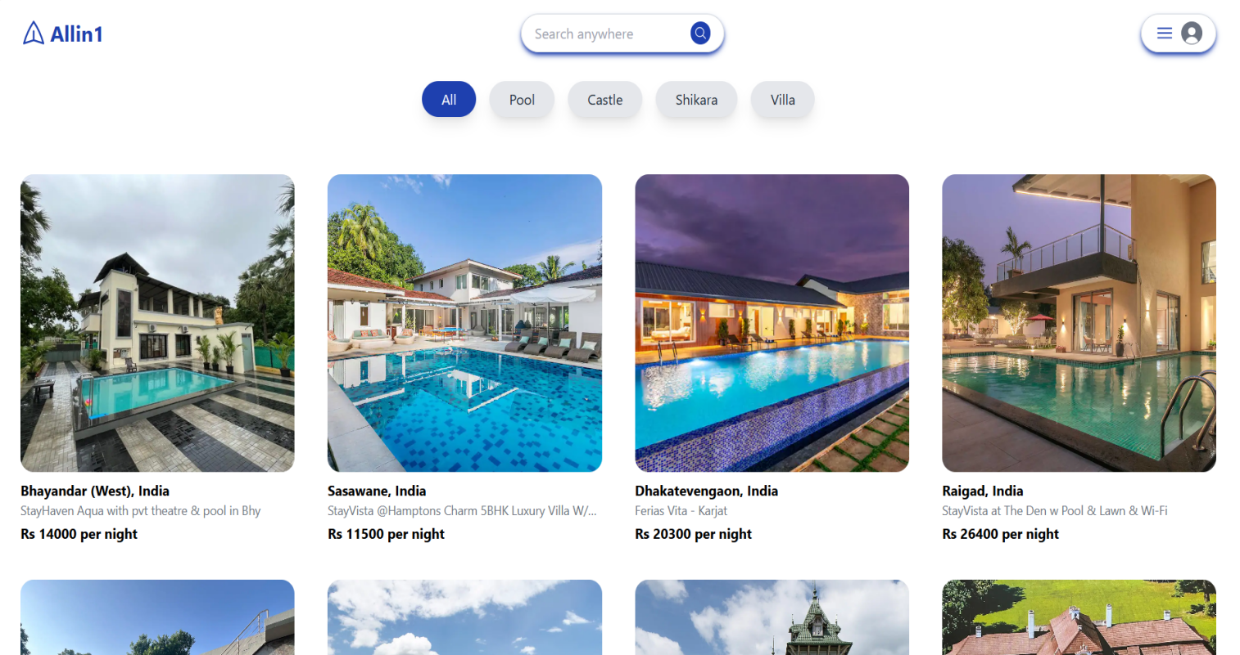



·  **Category demo**

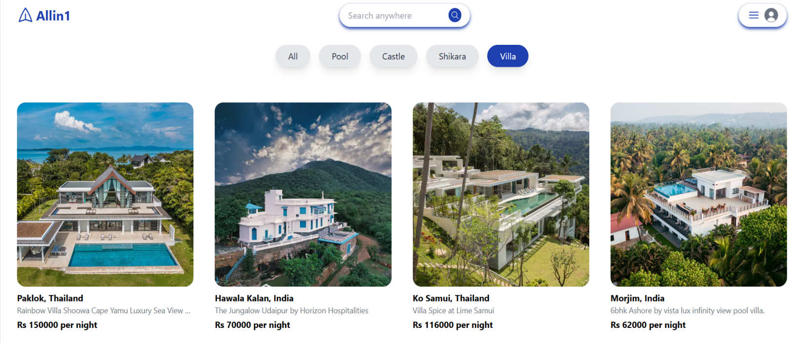

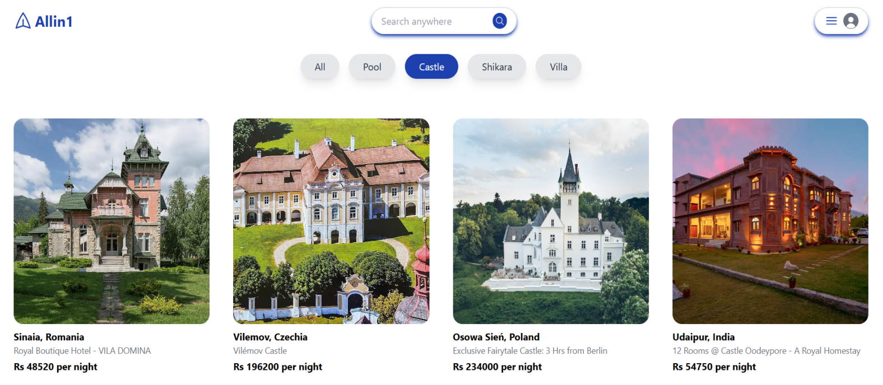

· Admin dashboard

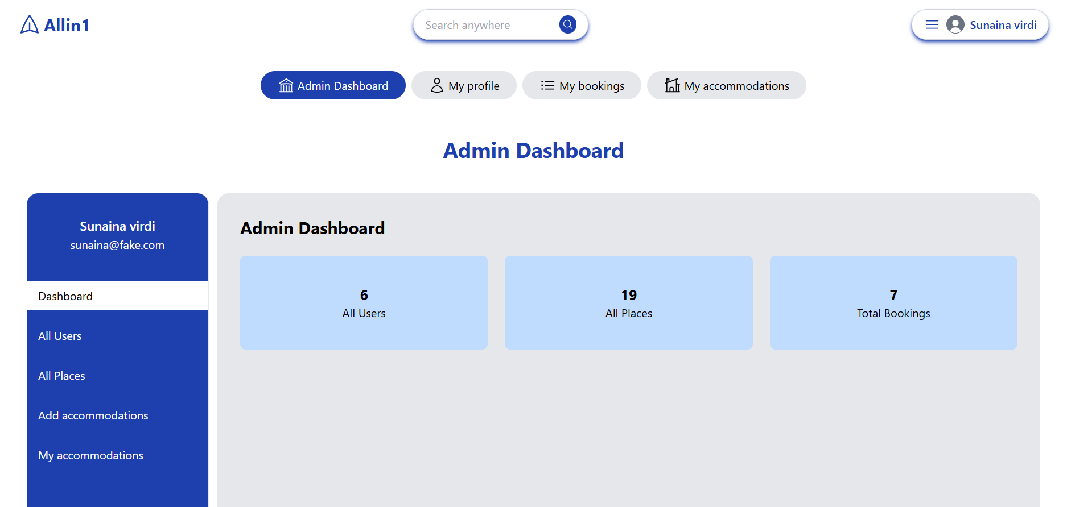

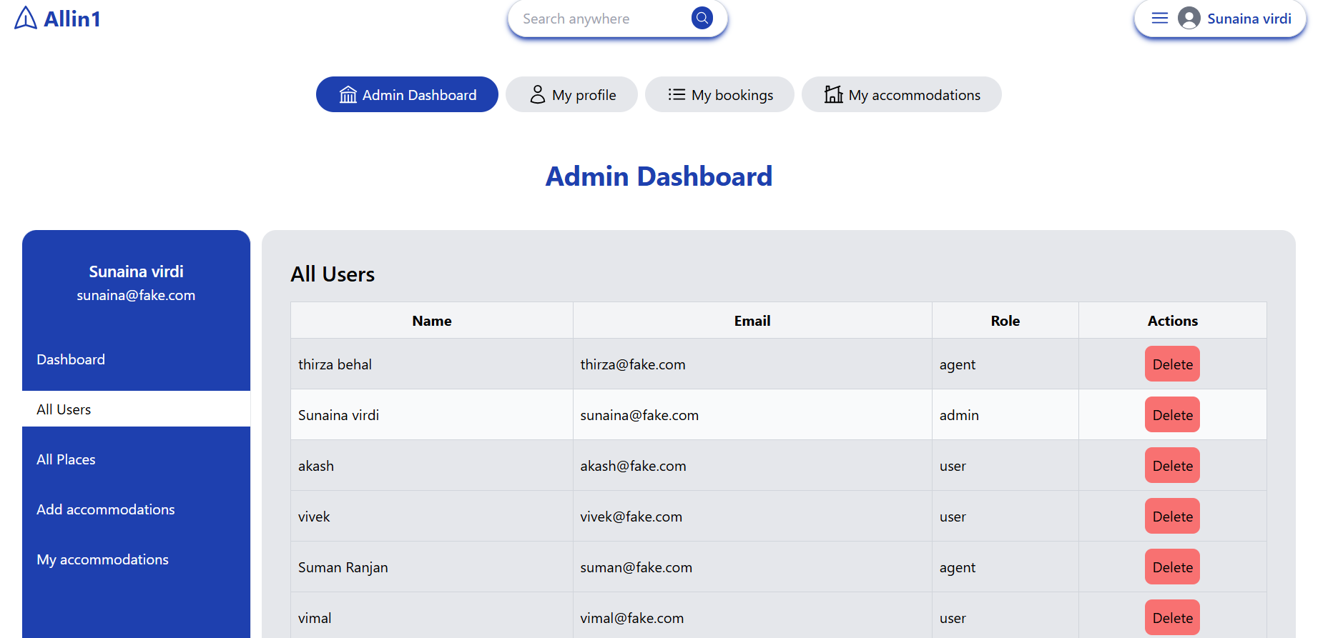

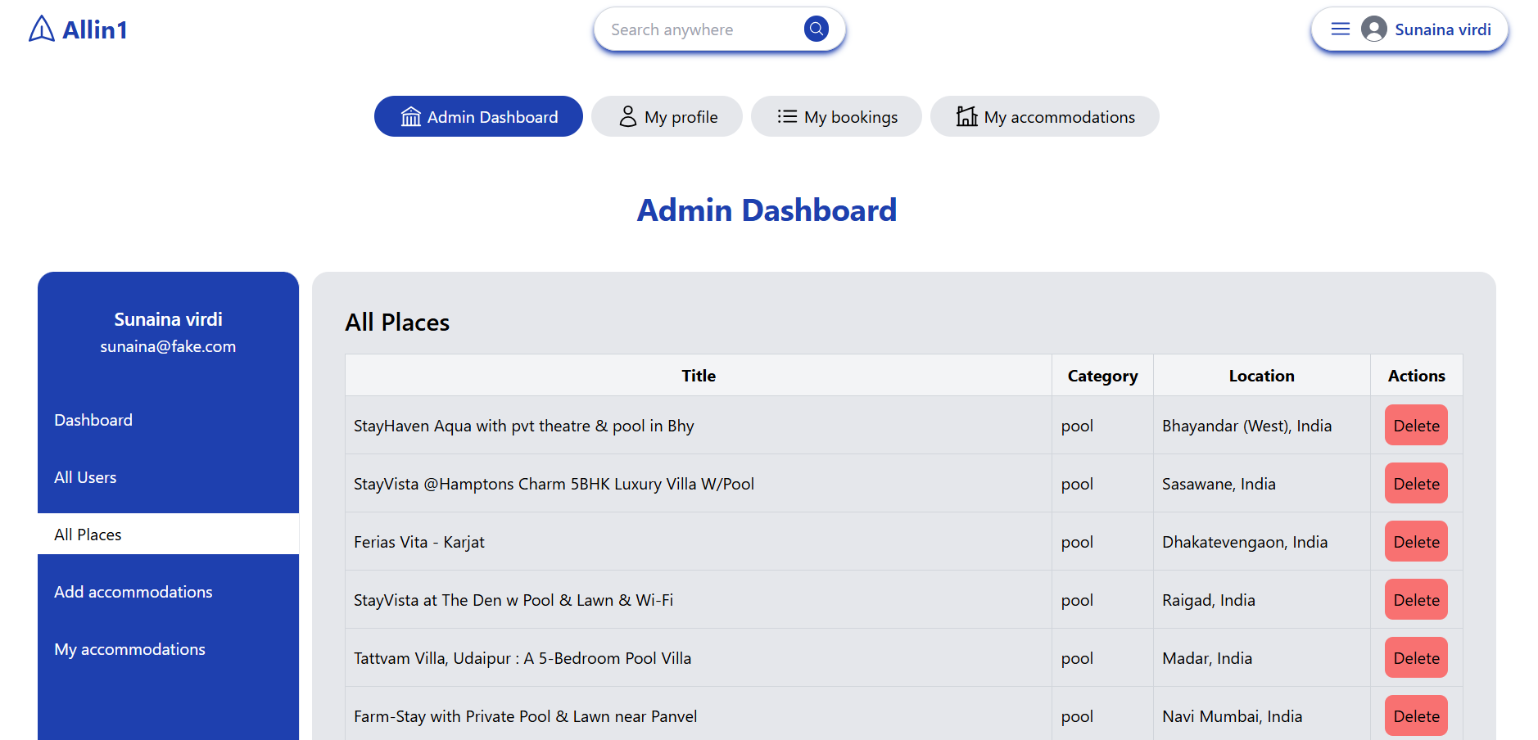

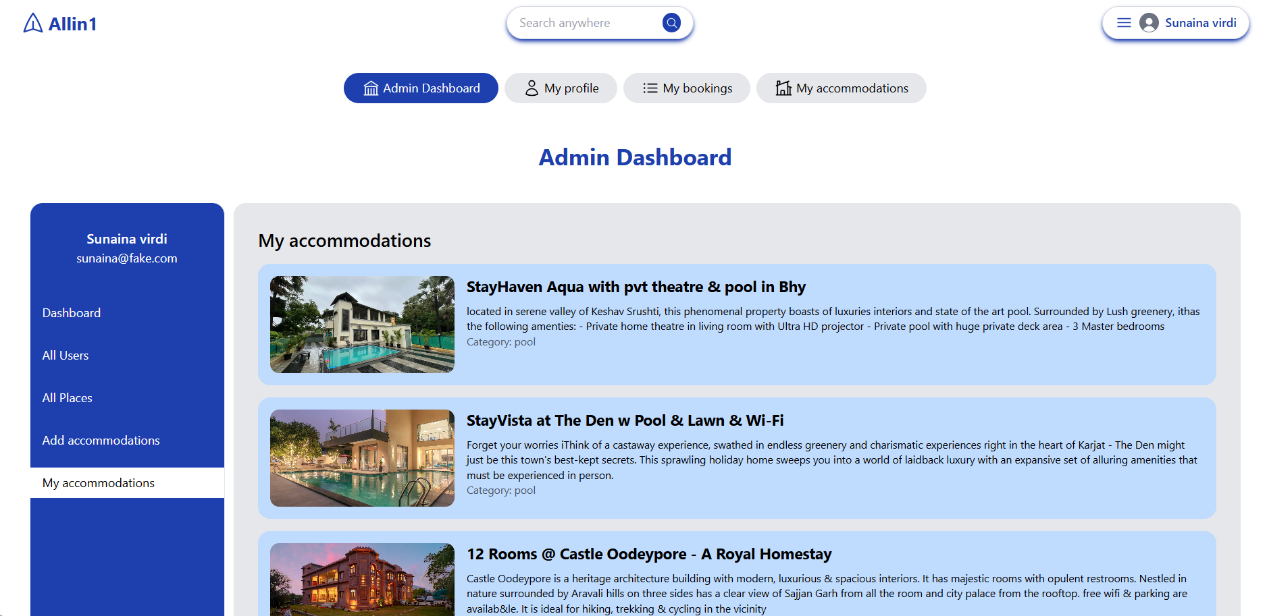

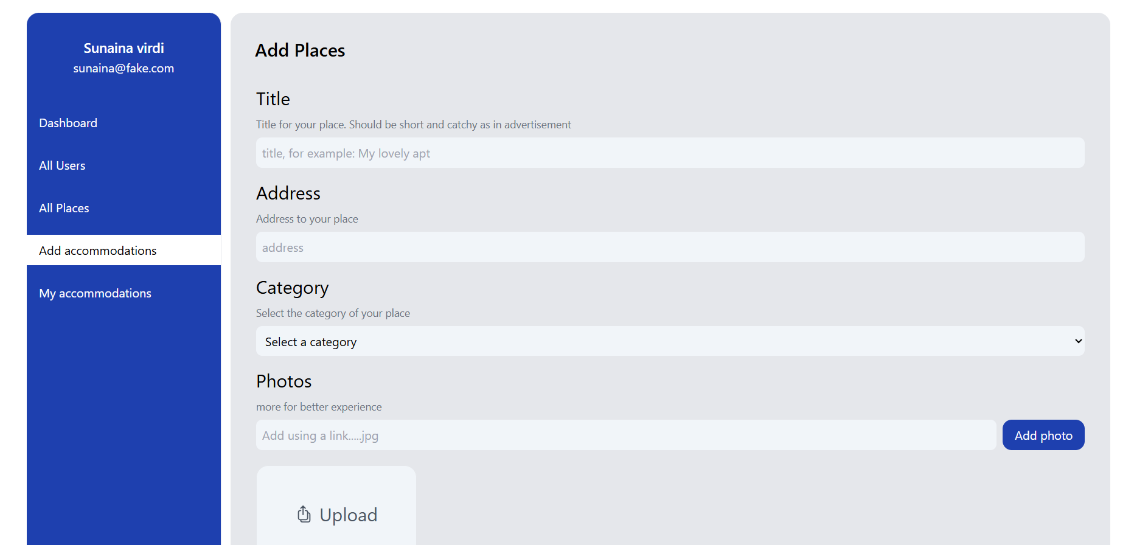

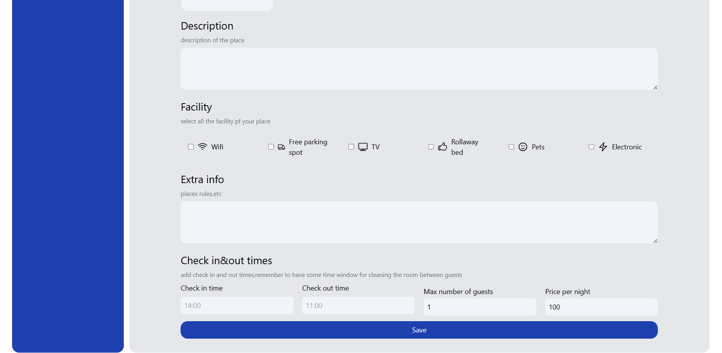

· Profile Page

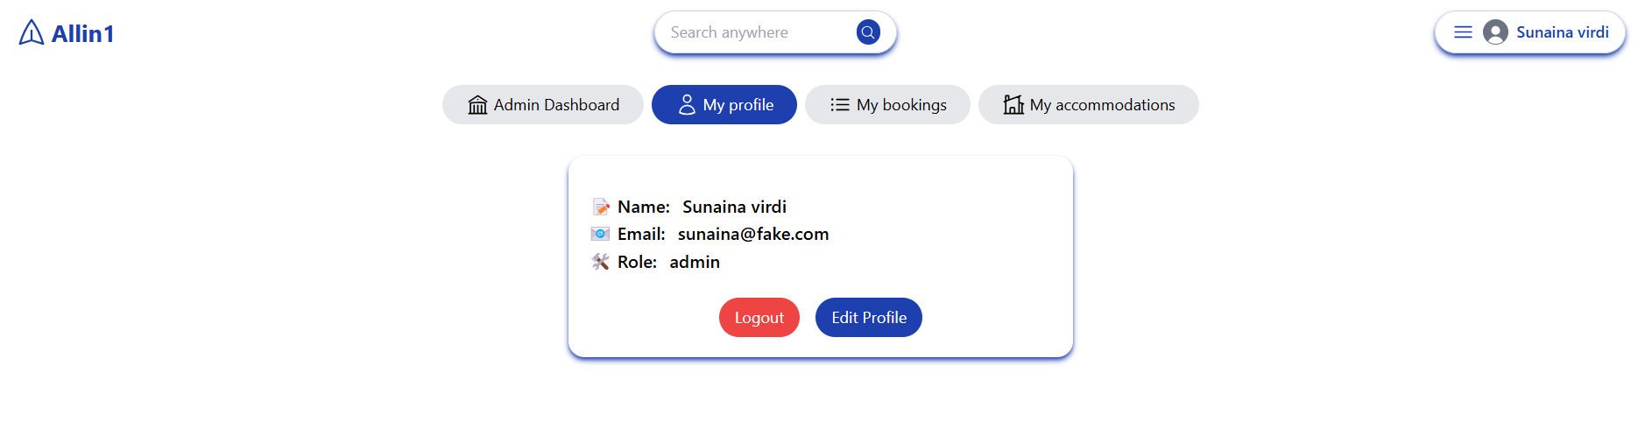

· Booking details

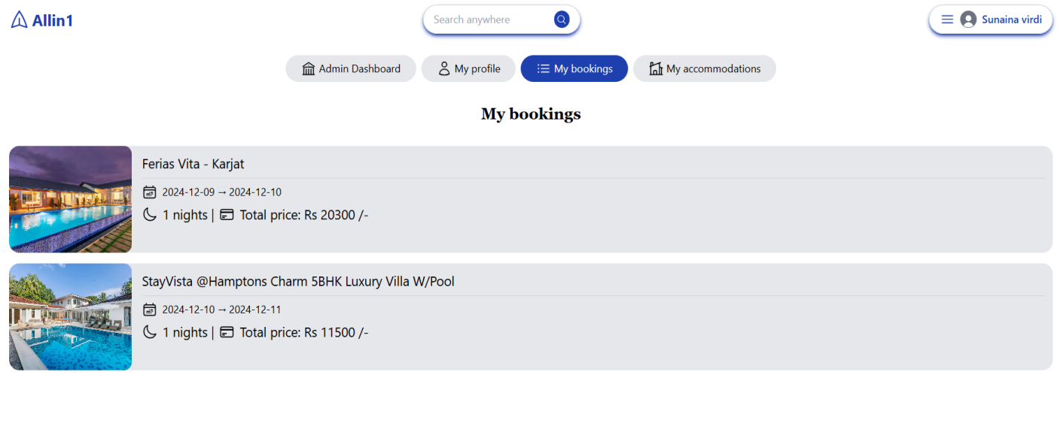

· Places details

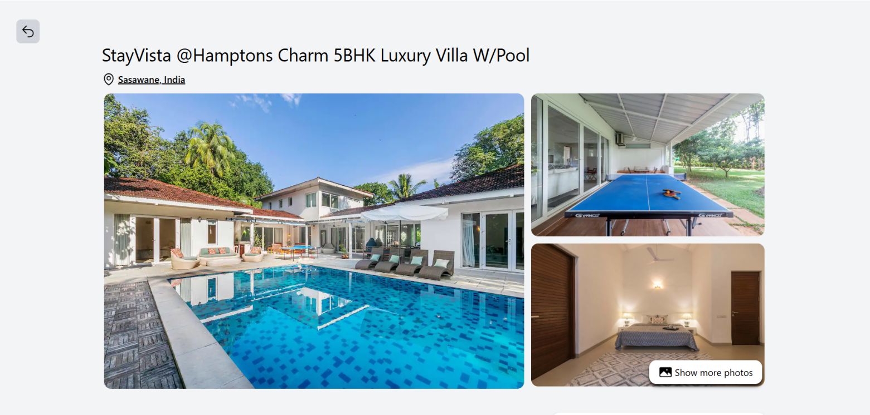

1. **Program's Structure Analyzing and GUI Constructing**

The Booking application is structured in a straightforward manner, as it is currently in the initial stages of development. The organization of files and folders is designed to facilitate ease of understanding and navigation.

* 1. **Program Structure**

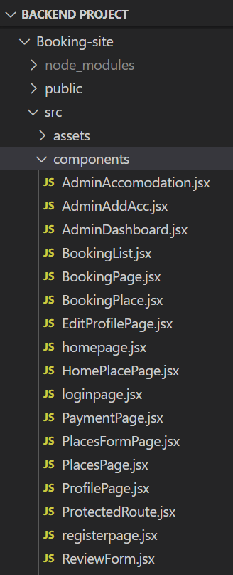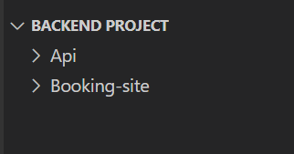The **All-in-One Booking Site** follows a structured organization, dividing the project into distinct folders for better management, scalability, and maintainability. Below is a detailed overview of the program structure:

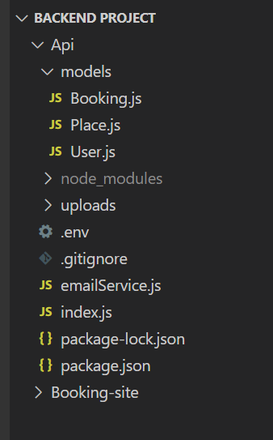

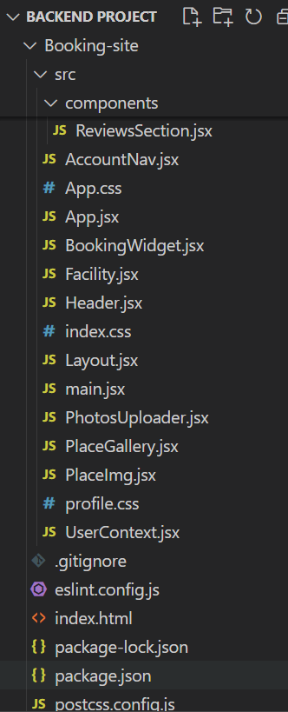

#### **/src/components**

This directory houses the core components of the application. The components are organized in a way that allows easy management of both frontend and backend functionalities. Some notable components include:

* + **App.jsx**: The main component that drives the entire application.
  + **BookingWidget.jsx**: Used for displaying booking-related features.
  + **ReviewsSection.jsx**: Displays user reviews for places.
  + **AdminDashboard.jsx**: The admin panel where users can manage content and users.
  + **UserContext.jsx**: Manages user state and context for easy access across the app.

Other components like **BookingPage.jsx**, **ProfilePage.jsx**, and **PlacesFormPage.jsx** handle the booking system, profile management, and place listings, respectively.

#### **/public**

This folder contains publicly accessible assets, such as static files, images, or icons, that are referenced throughout the application. It supports the seamless delivery of assets required by the frontend.

#### **/Api/models**

The **models** folder contains the core data models used in the application. These models represent the main entities in the system, including:

* **Booking.js**: Defines the schema and structure for booking-related data.
* **Place.js**: Handles the information about places users can book.
* **User.js**: Manages user data, including profiles and authentication details.

#### **/uploads**

This folder is responsible for storing uploaded files, such as images for places or user profile pictures. It enables the system to handle file uploads efficiently.

#### **index.js (Backend)**

This file serves as the entry point for the backend server, setting up configurations, routing, and middleware for API handling.

#### **package.json**

This file contains project metadata, including dependencies, scripts, and configurations needed to run the application. It ensures that the project can be easily set up and maintained by tracking all the necessary dependencies.

* 1. **GUI Construction**

The graphical user interface (GUI) of Booking site is designed with user experience in mind. Key aspects include:

* **Responsive Design**: The interface is built to be responsive, ensuring accessibility across various devices, including desktops, tablets, and smartphones.
* **User-Friendly Navigation**: Intuitive navigation is implemented to guide users through the auction process seamlessly, from viewing items to placing bids.
* **Visual Hierarchy**: Elements are organized based on importance, with clear calls to action (CTAs) to enhance user engagement.
* **Feedback Mechanisms**: Visual cues and messages provide users with immediate feedback on their actions, such as successful submissions or errors.

The GUI is developed using EJS templates combined with Bootstrap for styling. This approach allows for dynamic content rendering while maintaining a visually appealing layout.

1. **Code Implementation and Database Connections**

The Booking application is developed using Node.js and Express.js, integrated with MongoDB for data management. This section details the implementation of key features and database interactions within the application.

* 1. **Code Implementation**

The core implementation of the all in one booking application is structured around the following key components:

* **Server Setup**: The application initializes an Express server with middleware for handling sessions, static files, and URL-encoded form submissions. The server is configured as follows:

const express = require('express');

const cors = require('cors');

const mongoose = require('mongoose');

const bcrypt = require('bcryptjs');

const jwt = require('jsonwebtoken');

const User = require('./models/User.js');

const Place = require('./models/Place.js');

const Booking = require('./models/Booking.js');

const cookieParser = require("cookie-parser");

const imageDownloader = require('image-downloader');

const multer = require('multer');

const fs = require('fs');

const sendEmail = require('./emailService');  // Adjust the path if necessary

require('dotenv').config();

const app = express();

const bcryptSalt = bcrypt.genSaltSync(10);

const jwtSecret = 'asdfghjkl';

// middleware setup

app.use(express.json());

app.use(cookieParser());

app.use('/uploads',express.static(\_\_dirname+'/uploads'));

app.use(cors({

credentials:true,

    origin:'http://localhost:5173',

}));

* **Routing**: The application includes a set of routes to manage user, category, item, and bidding operations. Each route handles specific actions, such as adding, listing, editing, and deleting users or items. For example, the route for adding a user is implemented as follows:

app.post('/register', async (req, res) => {

  const { name, email, password, role } = req.body;

  try {

    const userDoc = await User.create({

      name,

      email,

      password: bcrypt.hashSync(password, bcryptSalt), // hashed version of a password for secure storage

      role: role || 'user', // Default to 'user' if not provided

    });

    res.json(userDoc);

  } catch (e) {

    res.status(422).json(e);

  }

});

app.post('/login', async (req, res) => {

  const { email, password } = req.body;

  const userDoc = await User.findOne({ email });

  if (userDoc) {

      const isPasswordCorrect = bcrypt.compareSync(password, userDoc.password);

      if (isPasswordCorrect) {

        // payload,secret key,expiration time,callback

        jwt.sign({email:userDoc.email,\_id:userDoc.\_id,name:userDoc.name},jwtSecret,{},(err,token) => {

            if(err) throw err;

            res.cookie('token',token).json(userDoc)

        });

      } else {

          res.status(401).json('Invalid password');

      }

  } else {

      res.status(404).json('User not found');

  }

});

* **Error Handling**: Comprehensive error handling is embedded in each operation to ensure a smooth user experience. For instance, when adding a user, any errors encountered during the database interaction are logged, and appropriate messages are sent to the user via session storage.
* **Database Operations**: The application defines CRUD operations for each entity (Users, Categories, Items, Bids). Each operation is structured to ensure proper interaction with the MongoDB database. For example, retrieving all users is done using:

app.post('/places', (req,res) => {

  const {token} = req.cookies;

  const {

    title,address,addedPhotos,description,price,

    facility,extraInfo,checkIn,checkOut,maxGuests,category,

  } = req.body;

  // console.log('received category:',category);

  jwt.verify(token, jwtSecret, {}, async (err, userData) => {

    if (err) throw err;

    const placeDoc = await Place.create({

      owner:userData.\_id,price,

      title,address,photos:addedPhotos,description,

      facility,extraInfo,checkIn,checkOut,maxGuests,category,

    });

    res.json(placeDoc); //sends the place’s data (placeDoc) as a JSON response to the client.

  });

});

app.get('/places',async(req,res) => {

  res.json(await Place.find());

});

* 1. **Database Connections**

MongoDB is used as the database for all in one booking site, allowing for flexible data storage. The application establishes a connection to MongoDB using the native MongoDB driver.

* **Connecting to MongoDB**: The connection to MongoDB is set up in a dedicated database.js file. Below is the code used to establish the connection:

// Update the URI to point to your local MongoDB instance

const uri = 'mongodb://localhost:27017/mydatabase';

// database connection

mongoose.connect(uri, {

   useNewUrlParser: true,

   useUnifiedTopology: true,

}).then(() => {

   console.log('Connected to local MongoDB');

}).catch((error) => {

   console.error('Error connecting to local MongoDB:', error);

});

* **Model Definitions**: While this application currently does not utilize Mongoose for schema definitions, the structure of collections is maintained through careful organization of routes and operations.
* **CRUD Operations**: The application leverages MongoDB methods to perform CRUD operations. For example, when adding a user, the following code is utilized:

const result = await usersCollection.insertOne(userObj);

By maintaining a structured codebase and establishing robust database connections, the Booking application ensures effective data management and a seamless user experience, vital for an online all in one booking platform.

* 1. **App.jsx**

import './App.css';

import { Route, Routes } from "react-router-dom";

import Homepage from "./components/homepage.jsx";

import Loginpage from './components/loginpage.jsx';

import Registerpage from './components/registerpage.jsx';

import AdminDashboard from './components/AdminDashboard.jsx';

import Layout from './Layout';

import { UserContextProvider } from './UserContext.jsx';

import axios from "axios";

import ProfilePage from './components/ProfilePage.jsx';

import EditProfilePage from "./components/EditProfilePage";

import PlacesPage from './components/PlacesPage.jsx';

import PlacesFormPage from './components/PlacesFormPage.jsx';

import HomePlacePage from './components/HomePlacePage.jsx';

import BookingPage from './components/BookingPage.jsx';

import BookingPlace from './components/BookingPlace.jsx';

import ProtectedRoute from './components/ProtectedRoute.jsx'; // Import ProtectedRoute

axios.defaults.baseURL = 'http://localhost:4000';

axios.defaults.withCredentials = true;

function App() {

  return (

    <UserContextProvider>

      <Routes>

        <Route path="/" element={<Layout />}>

          <Route index element={<Homepage />} />

          <Route path="/login" element={<Loginpage />} />

          <Route path="/register" element={<Registerpage />} />

          <Route path="/account/admin/dashboard" element={<ProtectedRoute>

              <AdminDashboard /></ProtectedRoute> }/>

          <Route path="/account/" element={<ProfilePage />} />

          <Route path="/account/profile/edit" element={<EditProfilePage />} />

          <Route path="/account/places" element={<PlacesPage />} />

          <Route path="/account/places/new" element={<PlacesFormPage />} />

          <Route path="/account/places/:id" element={<PlacesFormPage />} />

          <Route path="/place/:id" element={<HomePlacePage />} />

          <Route path="/account/bookings" element={<BookingPage />} />

          <Route path="/account/bookings/:id" element={<BookingPlace />} />

        </Route>

      </Routes>

    </UserContextProvider>

  );

}

export default App;

1. **System Testing**

System testing was a crucial phase in the development of the **All-in-One Booking Site**, ensuring the seamless functionality of its comprehensive features, including booking management, user authentication, and integration with third-party APIs. The testing process focused on evaluating the reliability, usability, and performance of the platform under various conditions.

**Testing Methodology**

The **Iterative Testing Approach** was utilized to ensure the accuracy and robustness of individual components and their integration into the system. Each feature was tested thoroughly before progressing to the next module.

1. **Feature-Specific Testing**:

* Validated key functionalities such as user registration, booking creation, payment processing, and cancellation workflows.
* Conducted CRUD operations for database interactions to confirm data integrity.

1. **Integration Testing**:

* Verified the seamless interaction between modules like booking, user profiles, and payment systems.
* Tested third-party API integrations (e.g., payment gateways and external booking systems) to ensure accurate data exchange and smooth operation.

1. **Error Handling and Edge Cases**:
   * Simulated various error scenarios, such as invalid payment details or overlapping bookings, to confirm appropriate error messages and recovery mechanisms.
   * Ensured that the application gracefully handled edge cases, such as high concurrency during peak booking periods.
2. **Performance Testing**:
   * Measured the platform’s response times and reliability under simulated high-load conditions to ensure scalability and consistent performance.
3. **User Interface Testing**:
   * Evaluated the platform for ease of navigation and accessibility, ensuring a user-friendly experience across all devices.
4. **Limitations**

Despite its robust features and user-friendly design, the **All-in-One Booking Site** has certain limitations that may impact its functionality and scalability in specific scenarios. Below are the key limitations identified in the system:

1. **Performance Under High Traffic**  
   While the platform is scalable, the current infrastructure may face performance challenges under high user loads. Managing simultaneous bookings and real-time data updates could lead to delays or slow responses without advanced load balancing or optimization techniques.
2. **Data Security Concerns**  
   Although the system implements authentication and secure data handling practices, it may still be vulnerable to advanced cyber threats such as data breaches or unauthorized access if additional layers of security (e.g., encryption, regular penetration testing) are not implemented.
3. **Scalability of the Database**  
   The current use of MongoDB is efficient for most scenarios, but scaling the database to handle massive amounts of data, such as millions of bookings or reviews, could require additional configurations like sharding or database optimization techniques.
4. **Limited Multi-language Support**  
   The platform does not currently support multiple languages, which could restrict its usability for a global audience or users who prefer non-English interfaces.
5. **Mobile Optimization**  
   Although the platform is responsive, certain aspects may require further optimization to deliver a seamless experience on smaller screens, especially for users with low-end devices.
6. **Absence of Advanced AI Features**  
   Features such as personalized recommendations, predictive analytics, or chatbots for customer support are not implemented, which could improve the overall functionality and user satisfaction.
7. **Conclusion**

In conclusion, the All-in-One Booking Site successfully delivers a robust solution to the challenges of modern booking systems, setting the foundation for a scalable and innovative platform. By integrating user-friendly features and leveraging cutting-edge technology, the project demonstrates its potential to significantly improve service management and user engagement. With continuous improvement and expansion, it holds the promise of becoming a leading solution in the booking industry.

1. **Future Scope**

The All-in-One Booking Site has immense potential for future development, ensuring it remains competitive, user-friendly, and scalable. Below are some of the possible enhancements and expansions that can be incorporated into the platform:

* **Advanced AI Integration**: Implementing AI-driven recommendations to provide personalized service suggestions based on user preferences and booking history.

Incorporating chatbots for real-time customer support to assist users with queries and resolve issues quickly.

* **Globalization** :-Introducing multi-language support to cater to a diverse and global audience.

Adding currency conversion features to enable users to make payments in their preferred currencies.

* **Mobile Application** : Developing native mobile applications for Android and iOS to complement the web platform, providing users with a seamless experience on mobile devices.

Adding offline capabilities in the mobile app for basic functionalities, such as viewing past bookings or saved places.

* **Advanced Analytics and Insights** :-Enhancing the admin dashboard with detailed analytics and reports, allowing service providers and administrators to track performance metrics, trends, and user engagement.

Providing data visualization tools to better understand booking patterns and optimize services.

1. **Bibliography References**

* MongoDB Documentation. (n.d.). Retrieved from [https://docs.mongodb.com](https://docs.mongodb.com" \t "_new)
* Express.js Documentation. (n.d.). Retrieved from [https://expressjs.com](https://expressjs.com" \t "_new)
* EJS Documentation. (n.d.). Retrieved from [https://ejs.co](https://ejs.co" \t "_new)
* Body-Parser Middleware Documentation. (n.d.). Retrieved from [https://www.npmjs.com/package/body-parser](https://www.npmjs.com/package/body-parser" \t "_new)
* "Node.js Design Patterns" by Mario Casciaro and Luciano Mammino.